Computer system -LAB1
Name: Nur E Siam
Student ID: 103842784

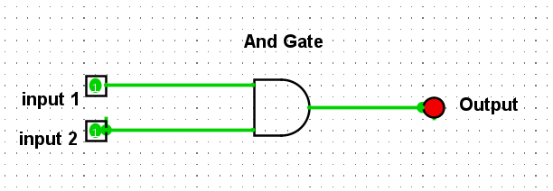
Fig: 1
Pin 1 | Pin 2 | output
0 | 0 | 0
0 | 1 | 0
1 | 0 | 0
1 | 1 | 1

Table: 1
Fig:2
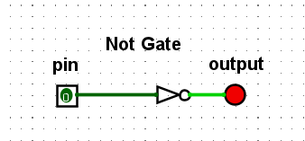

Pin | output
0 | 1
1 | 0
Table: 2

Fig: 3
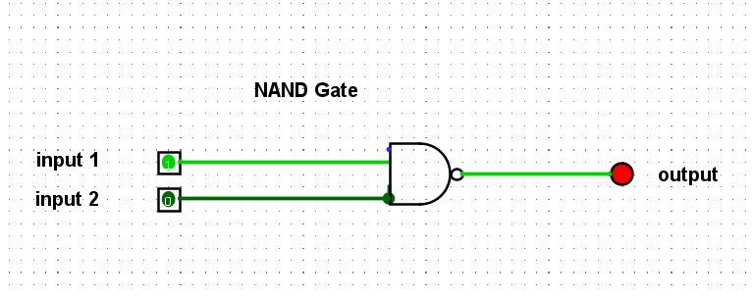
Table: 3
Pin 1 | Pin 2 | Output
0 | 0 | 1
0 | 1 | 1
1 | 0 | 1
1 | 1 | 0

Fig: 4
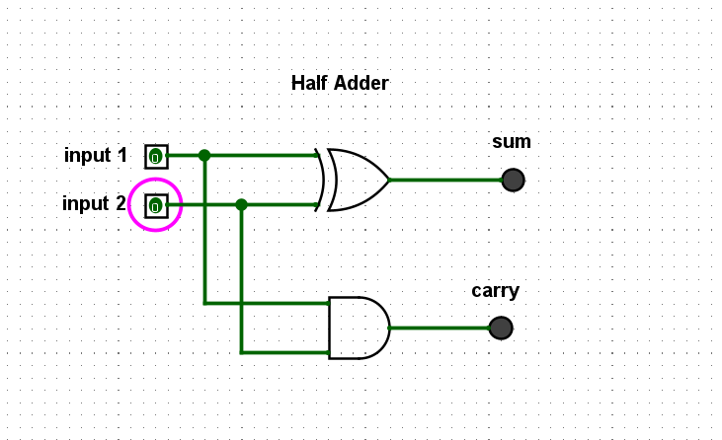
Table: 4
Input 1 | Input 2 | Sum output | Carry output
0 | 0 | 0 | 0
0 | 1 | 1 | 0
1 | 0 | 1 | 0
1 | 1 | 0 | 1

Fig: 5
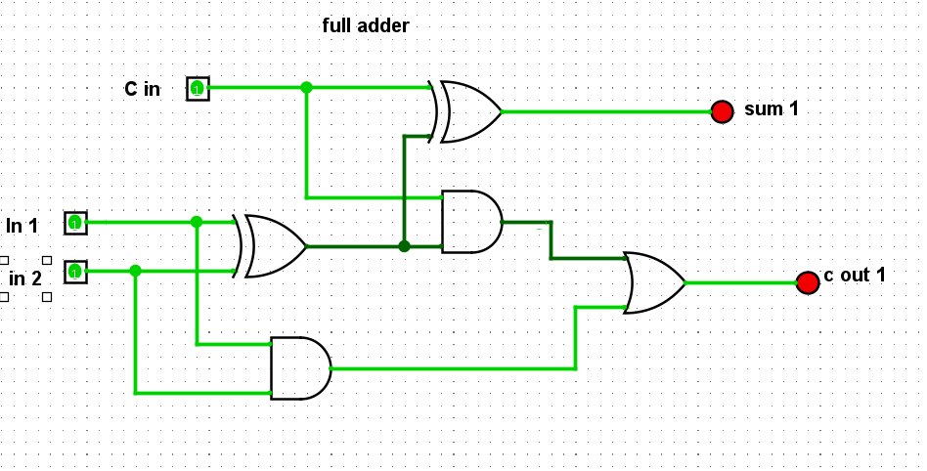

Table 5
Input 1 | Input 2 | Carry in | Sum | Carry out
0 | 0 | 0 | 0 | 0
0 | 0 | 1 | 1 | 0
0 | 1 | 0 | 1 | 0
0 | 1 | 1 | 0 | 1
1 | 0 | 0 | 1 | 0
1 | 0 | 1 | 0 | 1
1 | 1 | 0 | 0 | 1
1 | 1 | 1 | 1 | 1

